Appeal number: AA 103082013 / AA 103092013

The Upper Tribunal
(Immigration and Asylum Chamber)
Determined without a hearing
Field House Determination Sent
13 June 2014 20 June 2014

THE IMMIGRATION ACTS

Before

Upper Tribunal Judge Clive Lane

Between

SOFIE MANALLARI
XHEISON MANALLARI

Appellants

and

Secretary of State for the Home Department
Respondent

DETERMINATION AND REASONS

- The appellants are citizens of Albania. They appealed against a decision of the respondent to remove them which is dated 30 October 2013. The appeals were allowed by the First-tier Tribunal to limited extent that the applications for further leave to remain be reconsidered by the respondent in the light of the First-tier Tribunal’s comments.

- I granted permission on 28 April 2014 on the basis that the determination was arguably flawed for each of the reasons asserted by the appellants in their grounds of appeal dated 8 April 2014. I directed that, if the respondent did not object in writing within 14 days of having received my directions, I would set aside the First-tier Tribunal determination. The Upper Tribunal has received no response from the Secretary of State. I do not propose to say more than to observe that the First-tier Tribunal erred in law by remitting the matter to the Secretary of State in circumstances where there was absolutely no reason whatever to do so. The First-tier Tribunal should have determined the appeals before it on the basis of the evidence adduced by both parties. Its failure to do so constituted an error of law such that the determination and any findings of fact should be set aside. There has been a total failure by the First-tier Tribunal to adjudicate in these appeals and I find that it is appropriate to direct that the decision be remade in the First-tier Tribunal (not before First-tier Tribunal Judge Pears).

DECISION
The determination of the First-tier Tribunal dated 20 January 2014 is set aside. I direct that the First-tier Tribunal shall remake the decisions (not Judge Pears)

Signed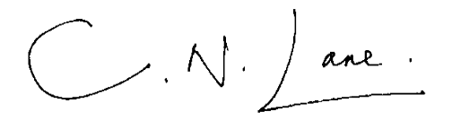

Upper Tribunal Judge Clive Lane

Dated 13 June 2014

